Video #1:
1 - know context:
- functional requirements (fr)
- non functional requirements (nfr)

2 - prioritize fr & nfr
- YAGNI

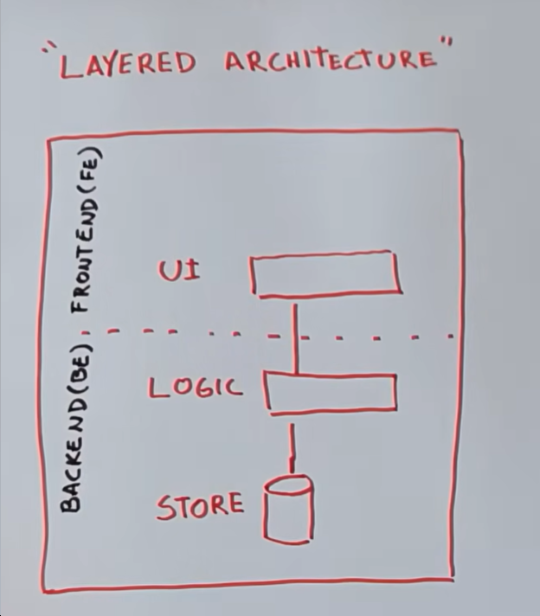
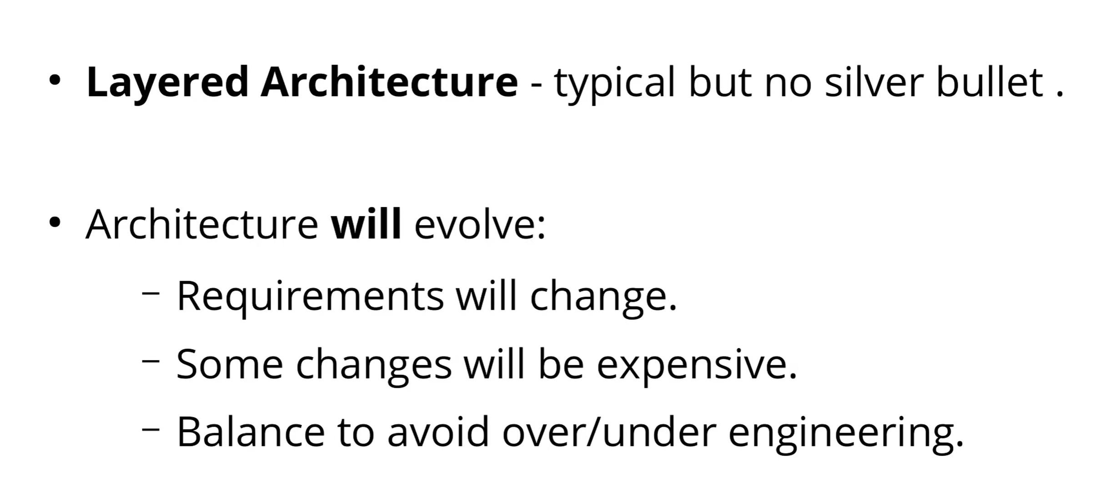

___________________________________________________________________________________

Video #2:

- what do we need to scale? amount of concurrent users or amount of data?

- Vertical Scaling : making node/server stronger and faster by adding more hardware

- Horizontal Scaling : splitting the load between different servers (preferred scaling way)
- gives you scalability but also reliability as you will have more redundancy
- if servers have a state then you will face CAP theorem, otherwise you can use load balancer that will direct traffic among them
- database has state
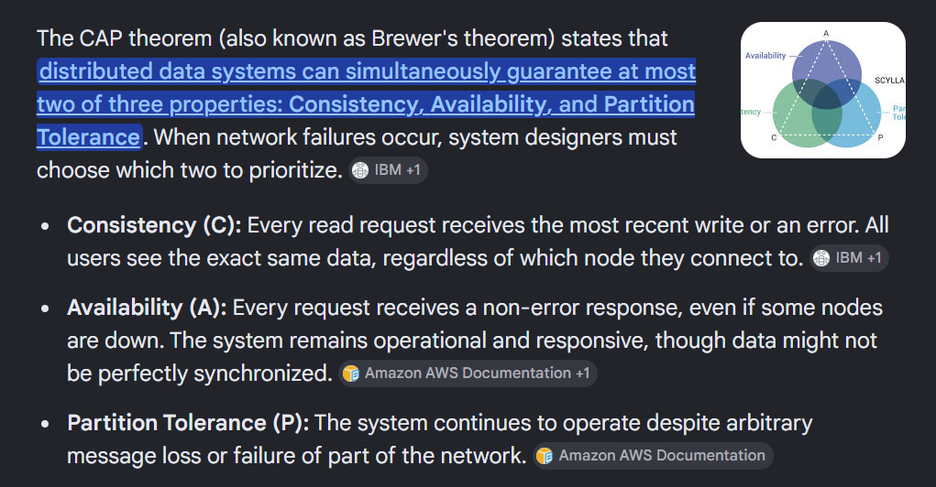
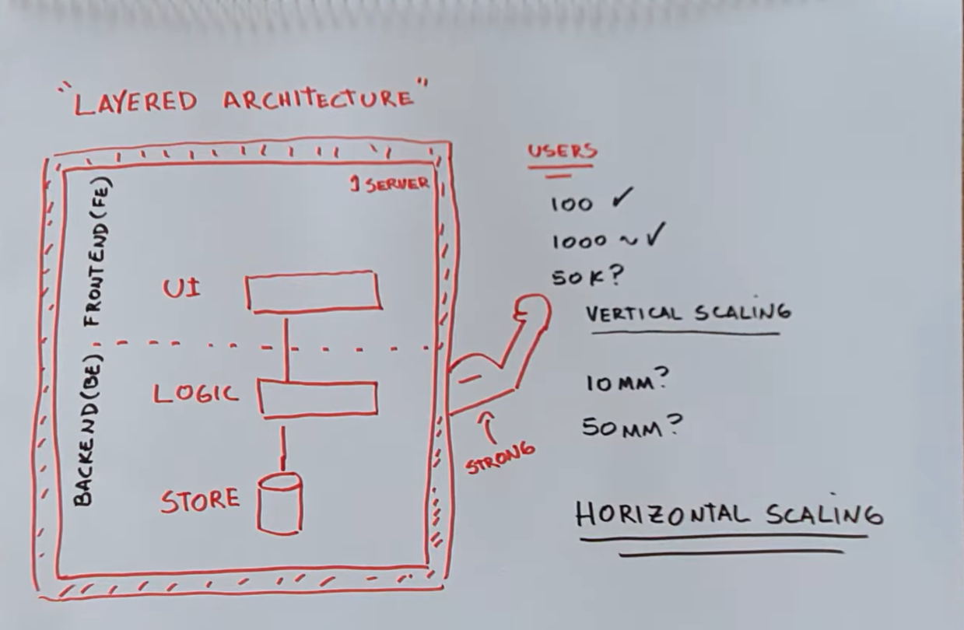
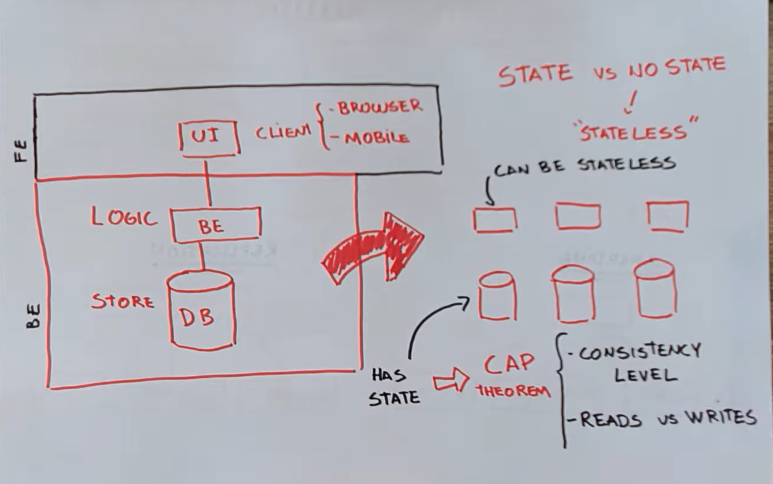

- You should consider the following
- Consistency Levels
- strict consistency : when saving, data is immediately available to everyone
- eventual consistency : there's a delay between a write and when all the readers can see that write

- Read more vs Write more

- Sharding : split the data between different servers
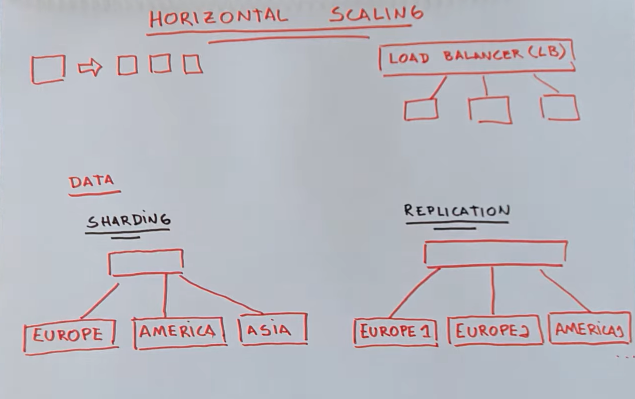
- Replications : multiple copies of data in different servers
- userful for read-intensive applications
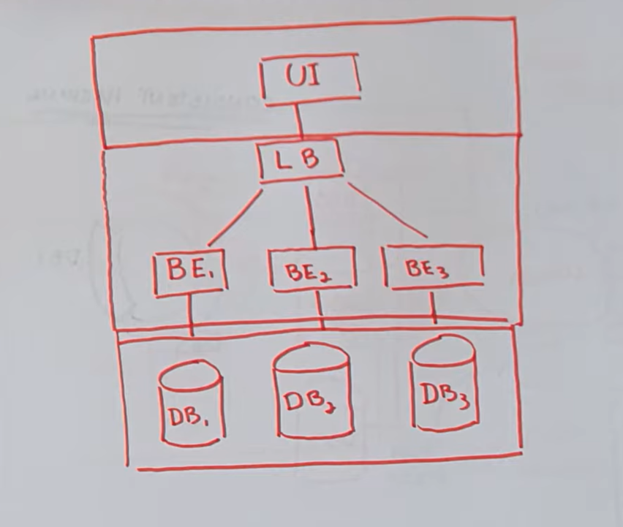
Trade offs

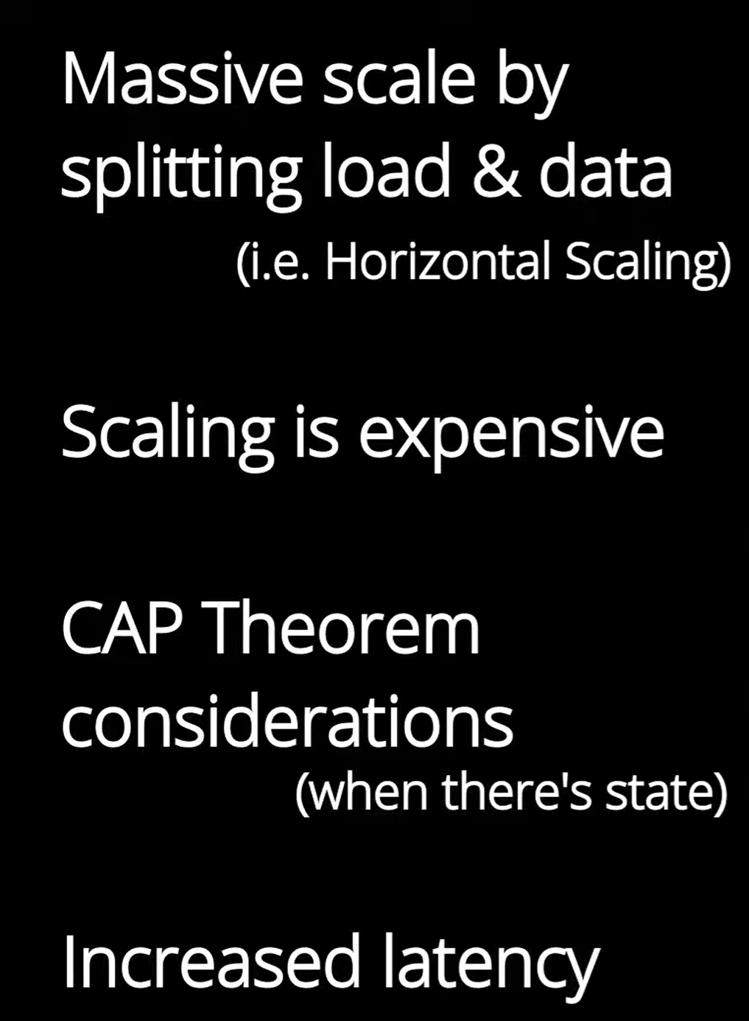

___________________________________________________________________________________
Video #3

